ASSINGMENT – 34

SQL CODE:

CREATE PROCEDURE d0_any_table(p_table_name VARCHAR2) IS

BEGIN

EXECUTE IMMEDIATE 'DROP TABLE ' || p_table_name;

END;

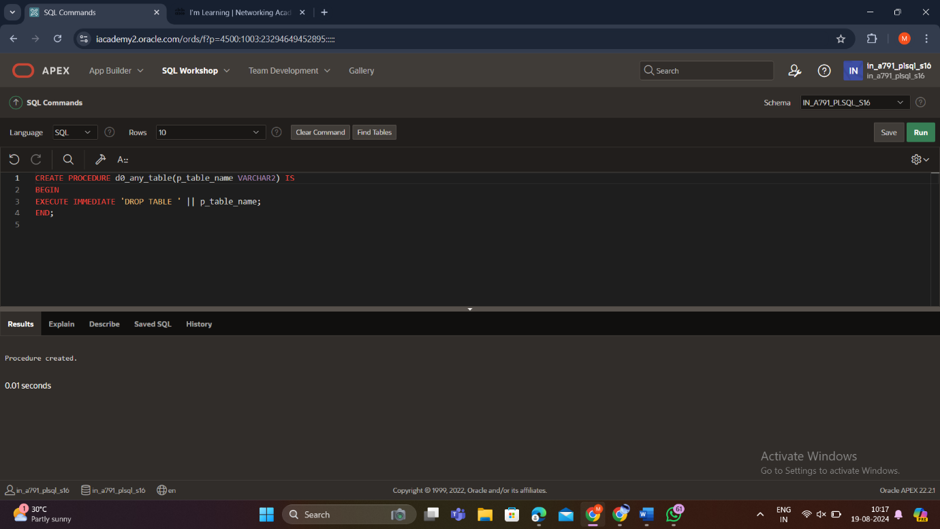

OUTPUT:

BEGIN d0_any_table('EMPLOY');

END;

